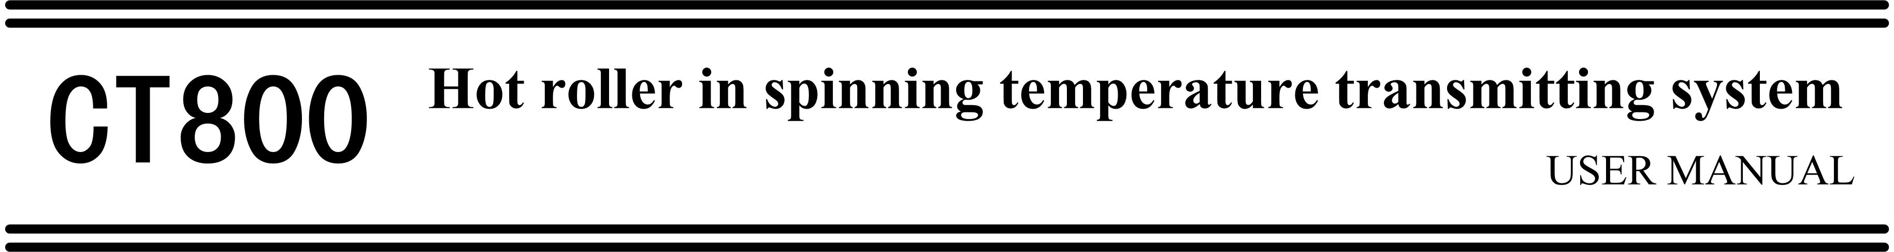

CT800 temperature transducer system is the temperature detection system for heat roller ,it embeds Pt100 temperature transducer into the shell of heat roller ,and connects with the revolve part accept the energy launched by the stator ,and launch the temperature signal to the stator part through ADC；The stator part connect with the transducer part through coaxial cable, the transducer part turns into 4-20mA standard signal through ADC.
CT800 adopts digital transporting and digital control port circuit technology, has strong anti-disturbance and low temperature drift .There is a 9mm operation distance between the revolve part and stator part , avoiding friction and crash ,the transducer part is installed in the electrical cabinet, aloof from the dirty operation environment in high temperature site.
There are 1~4 varieties temperature spots to choose from .It adjust the device for various hot roller and motor.
- Model Series

Equipment | Temperature measurement points
Equipment | One point | Two point | Three point | Four point
Stator | CT800S
Rotator | CT801R | CT802R | CT803R | CT804R
Transducer | CT801C | CT802C | CT803C | CT804C

- Appearance
  - Rotator part

  - Stator part

  - Transducer unit

- Primary Technical Characteristics
- Transducer number：1～4；
- Input signal：Pt100 hot resistance(RTD)；
- Measuring range：0～300℃；
- Measuring accuracy：0.1%；Output signal：4～20mA constant current output；
- Supply power：22～35VDC，or 17～27VAC，2A；
- Rotator speed：≤10000RPM；
- Environment temperature：Rotator part：0～100℃；
Stator part：0～100℃；
Transducer unit：0～70℃；
- Relative humidity：0～90%RH，no condensate.

- Assembly Diagram

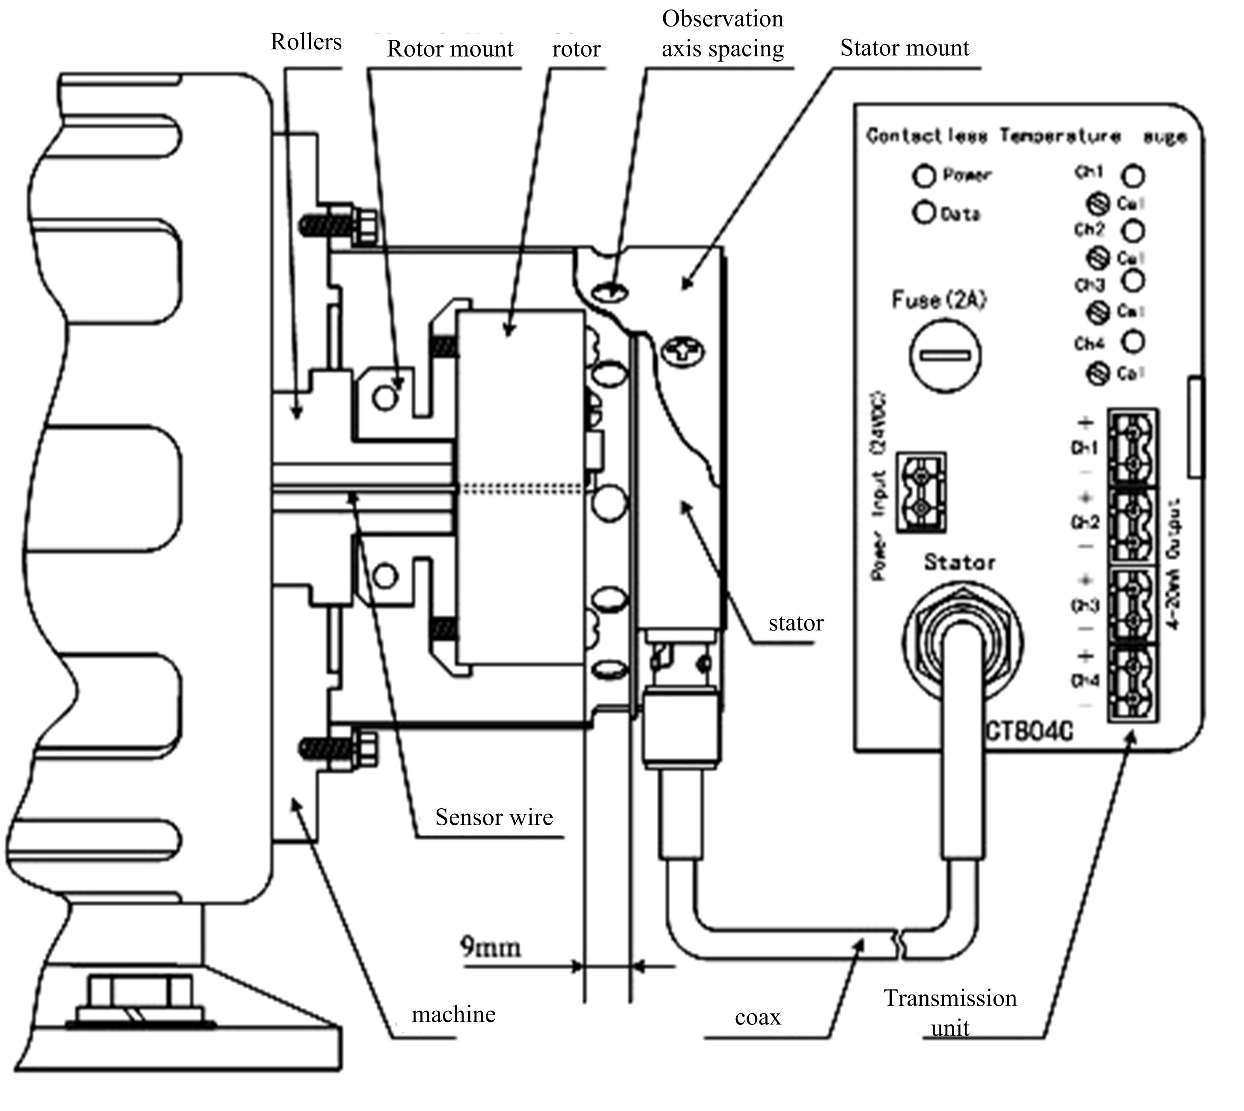

- Features
- Totally enwrap the rotator (reduce the external disturbance as much as possible)
- 0～300℃ measuring range
- High-precision (maximum deviation 0.3℃)and high stability
- Little temperature drift caused by environment temperature change
- Data output and signal output based on digital transducer change
- Adjust 1-4 temperature detection area
- Clear monitor circuit and system condition
- Automatic calibration in 5 second
- Intelligent fault respond mode

- System Calibration
If we input 100.000、138.506、175.856、212.052Ω after the system is connect to standard resistance box and power on, the output outcome should be 4.000、9.333、14.667、20.000mA respectively. If calibration is required, applying 212.052Ω signals and adjusting the corresponding Cal potentiometer to achieve the 20.000mA output.
The corresponding Cal potentiometer could also be adjusted if there is a deviation between the actual temperature and measured value caused by the sensor error.

- Troubleshooting

Indicator | Indicator Status | Condition | Corrective Action
Power Indicator | Solid On | Normal Working condition | ——
Power Indicator | Flash fast（5Hz） | Irregularity in the power supply of Rotator part | Check the spacing between Rotator part and Stator part
Power Indicator | Flash slow（2Hz） | Irregularity in the power supply of Stator part | Check power source
Power Indicator | Off | No power supply | Check the power supply and power connection
Power Indicator | 5s on /5s off | Insufficient rotary power, data not be received. | Check the spacing between Rotator part and Stator part
Data Indicator | Solid On | Normal Working condition | ——
Data Indicator | Flickering | Intermittent transmission errors | Check the spacing between Rotator part and Stator part
Data Indicator | Lights off | Data not received | Check the spacing between Rotator part and Stator part
Temperature indicator （Ch1~4） | Normally on | Normal Working condition | ——
Temperature indicator （Ch1~4） | Flash fast（5Hz） | Out of range of measure or the sensor is damaged | Check the sensor and connection
Temperature indicator （Ch1~4） | Flash slow（2Hz） | Open circuit in 4～20mA loop | Check the connection and continuity of current loop

- Service and Maintenance
 This controller is under warranty for 12 months since the day of purchase (the warranty only stands if the problem is caused by the malfunction due to manufacturing). Any repairment for damages caused by improper use of the controller will be charged. The controller is provided with lifetime maintenance and repair on cost.
 Please keep the controller in a dry place with air and NO corrosive gas.




